HSBC 面试准备
自我介绍
●Can you introduce your self and previous experience？
【加入自然的过渡 选择一句即可】
1.感谢面试官：
- Thank you for the opportunity to interview today.
- I appreciate you taking the time to interview with me.
2.礼貌开场：
- Okay, sure. Let me just walk you through my profile brief and then we can go from there.
- Following your request, I'd like to introduce myself and tell you about my background.
- To begin, I'd like to give you a brief overview of my professional experience.
3.结束：
- That's all, thank you.

项目经验
- What is the work that you were pround of in the previous?
  - 如果面试官继续追问细节，但可能不太会回答： Sure，I will try my best to answer this question. But If I could not express it clearly, please allow me to use Chinese to reply.
[先尝试回答，实在不会再用中文回答]

职业规划
- What are your goals / Can you describe your expected career path / What factors are most important to you when considering a new job opportunity？
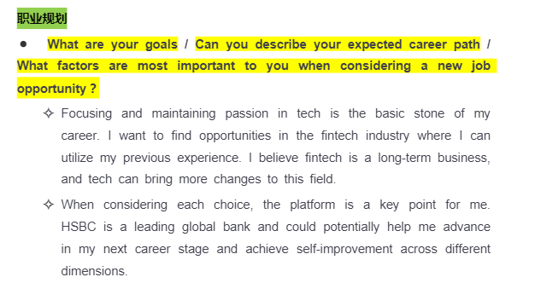
- Why are you considering a move to HSBC at this point in your career / What do you know about HSBC?
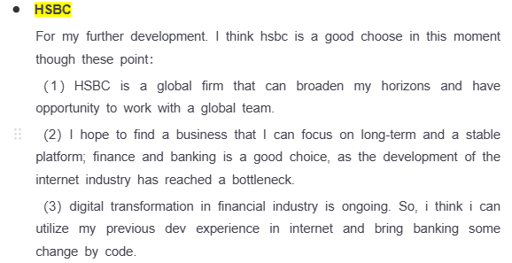
- How do you envision your role evolving within HSBC?
- Why did you leave your previous Job?
- If you could change anything about your career so far, what would it be?
  - 例如：I will change my career choose in this moment and want the scope of job and platform could be closely with international. You know, Internationalization is a trend, and currently, local companies are seeking and making a move overseas.

个人的优缺点
- Your competitive advantage/list your top 3 qualities / why would we hire you instead of anyone else / Why should we hire you / what do you think you can contribute to team”
- 这个问题评估候选人跟岗位的适配性以及录用后对部门有用的部分
- 回答纬度：行业经验➕工作技能&工作核心core to the job➕个人特点self personality and quality
- Your weekness / What aspects need improvement
注意：一定是不触及汇丰价值观的weeknees
  - Sure. I need to learn more about how to work in global firm and improve my English public communication skill. But this will not be a big challenge, as I am very willing to keep learning and taking some courses.
团队合作
- Have You Ever Had a conflict or different view point with a Team Member? How Did You Handle It? 这个问题让候选人描述与团队成员发生冲突的情况以及处理方式，以展示其团队合作和冲突解决技能。
- Describe the team atmosphere you ideally hope for. 所期望的理想中的团队氛围

问题解决能力
- What’s the most stressful/challenge situation you’ve faced at work so far? How did you handle it? 这个问题评估候选人在压力下的问题解决能力。
- Tell me a Time you failed and what you Learn from It?
分成问题-解决-教训 三方面回答
- If assigned with multiple tasks at the same time, how would you organize yourself to produce quality work under tight deadlines? 这个问题评估候选人的多任务处理和时间管理
- Can you describe a time when your stress resulted in making errors at work? 这个问题评估候选人的自我意识和责任感。搞砸工作后的处理方式

压力管理
- Tell me a Time you failed and what you Learn from It
- How do you prepare for a presentation to important [clients/stakeholders/the executive board] the day before it’s due? 这个问题评估候选人在截止日期前处理压力和优先级划分的能力。
- How would you respond if your manager gave you negative feedback in front of your peers? 这个问题衡量候选人的情绪韧性和专业素养。
- How would you deal with frequent changes at work? For example, if stakeholders were indecisive about a project’s requirements, or if new members joined your team. 这个问题考察候选人的适应性。

反问环节
What is the daily routine looks like in this job？
What is the expected and key KPI for this role？
Could you introduce the team with me?
What is future career advancement paths of this job and team development directions?

